**CS 224 - DIGITAL DESIGN**

**LAB NO. 6**

**SECTION 6**

**ALARA ZEYBEK**

**22102544**

**Lab 6 Cache Report 1**

**Matrix with N=50:**

**Part a)**

**Row Summation Data Table:**

|  |  |  |  |  |  |  |  |  |  |  |
| --- | --- | --- | --- | --- | --- | --- | --- | --- | --- | --- |
| **Block Size**  **\**  **Capacity** | **4** | | **8** | | **16** | | **32** | | **64** | |
| **Miss rate**  **(%)** | **# of misses** | **Miss rate**  **(%)** | **# of misses** | **Miss rate**  **(%)** | **# of misses** | **Miss rate**  **(%)** | **# of misses** | **Miss rate**  **(%)** | **# of misses** |
| **0.5 kB** | 70 | 1843 | 97 | 2553 | 97 | 2553 | 97 | 2552 | 76 | 2006 |
| **1 kB** | 44 | 156 | 61 | 1606 | 64 | 1617 | 65 | 1638 | 76 | 2006 |
| **2 kB** | 43 | 1128 | 41 | 1071 | 64 | 1693 | 97 | 2552 | 76 | 2006 |
| **4 kB** | 42 | 1114 | 40 | 1043 | 39 | 1026 | 65 | 1707 | 76 | 2006 |
| **8 kB** | 41 | 1092 | 38 | 1005 | 37 | 968 | 36 | 961 | 30 | 784 |

**Column Summation Data Table:**

|  |  |  |  |  |  |  |  |  |  |  |
| --- | --- | --- | --- | --- | --- | --- | --- | --- | --- | --- |
| **Block Size**  **\**  **Capacity** | **4** | | **8** | | **16** | | **32** | | **64** | |
| **Miss rate**  **(%)** | **# of misses** | **Miss rate**  **(%)** | **# of misses** | **Miss rate**  **(%)** | **# of misses** | **Miss rate**  **(%)** | **# of misses** | **Miss rate**  **(%)** | **# of misses** |
| **0.5 kB** | 24 | 656 | 12 | 342 | 7 | 192 | 5 | 127 | 4 | 111 |
| **1 kB** | 23 | 644 | 12 | 330 | 6 | 178 | 4 | 104 | 3 | 77 |
| **2 kB** | 23 | 639 | 12 | 325 | 6 | 171 | 3 | 94 | 2 | 60 |
| **4 kB** | 23 | 637 | 12 | 321 | 6 | 167 | 3 | 90 | 2 | 54 |
| **8 kB** | 23 | 636 | 12 | 320 | 6 | 166 | 3 | 87 | 2 | 51 |

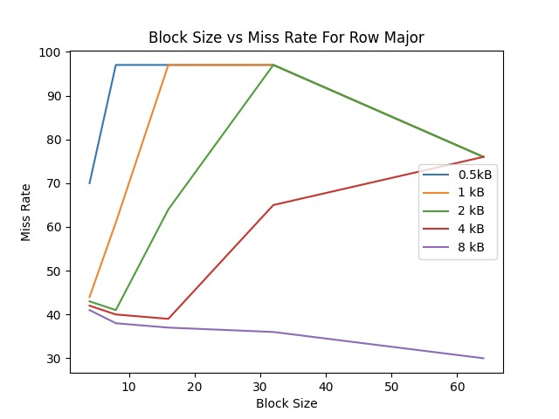

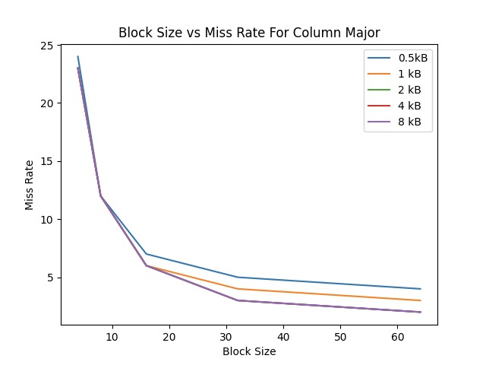

**Part b)**

**Good hit rate:** Cache size is 8 kB and block size is 64. (hit rate is %70)

**Medium hit rate:** Cache size is 1 kB and block size is 4. (hit rate is %56)

**Bad hit rate:** Cache size is 0.5 kB and block size is 8. (hit rate is %3)

**In Direct Mapping:**

|  |  |  |  |  |  |  |
| --- | --- | --- | --- | --- | --- | --- |
| **Block Size**  **\**  **Capacity** | **4** | | **8** | | **64** | |
| **Miss rate**  **(%)** | **# of misses** | **Miss rate**  **(%)** | **# of misses** | **Miss rate**  **(%)** | **# of misses** |
| **0.5 kB** | - | - | 97 | 2553 | - | - |
| **1 kB** | 44 | 156 | - | - | - | - |
| **8 kB** | - | - | - | - | 30 | 784 |

**Row Summation with Fully Associative Cache (LRU replacement policy):**

|  |  |  |  |  |  |  |
| --- | --- | --- | --- | --- | --- | --- |
| **Block Size**  **\**  **Capacity** | **4** | | **8** | | **64** | |
| **Miss rate**  **(%)** | **# of misses** | **Miss rate**  **(%)** | **# of misses** | **Miss rate**  **(%)** | **# of misses** |
| **0.5 kB** | - | - | 97 | 2556 | - | - |
| **1 kB** | 25 | 657 | - | - | - | - |
| **8 kB** | - | - | - | - | 29 | 735 |

In the good hit rate scenario, the cache capacity is 2^13 byte (8 kb) and 1 block is 2^8 Byte (it has 64 words). So, in fully associative cache there is 1 set that holds 32 blocks. Therefore, we see the best hit rates in 8kB because bigger cache capacity reduces the capacity misses. However, in the direct mapping our good hit rate was %70, but in fully associative cache, our good hit rate changed to %71 and the number of misses decreased from 784 to 735. Since it is a big change, we cannot disregard it and its reasons. LRU is one of the reasons. With LRU, you only overwrite the least used data, and it decreases the conflict misses. However, in direct mapping you don’t use any replacement technic, you just trash data that is found with a mapping function.

In the medium hit rate scenario, the cache capacity is 2^10 byte (1 kb) and 1 block is 2^4 Byte (it has 4 words). So, in fully associative cache there is 1 set that holds 64 blocks. In the direct mapping our medium hit rate was %56 but in fully associative cache, our medium hit rate changed to %75 and the number of misses increased from 156 to 657. Since the associativity degree increases from 1 to full, the conflict misses decrease, therefore we got a better hit rate. In addition to that with LRU, we decrease the conflict misses. Thus, in general we expect to get better results by using LRU.

In the poor hit rate scenario, the cache capacity is 2^9 byte (0.5 kb) and 1 block is 2^5 Byte (it has 16 words). So, in fully associative cache there is 1 set that holds 16 blocks. In the direct mapping our poor hit rate was %3 and in fully associative cache, our poor hit rate didn’t change still %3 and the number of misses increased from 2553 to 2556. Since the associativity degree increases from 1 to full, normally we expect to see that conflict misses to decrease, however in this case, it increases. Since direct mapping and fully associative miss count are very close to each other, the reason for this can be the fact that cache capacity is very small for our matrix, and we may not comfortably observe the differences between direct mapping and fully associative cache. So, the experimental result may have been due to the selection of sizes, writing of the program code or any other factor.

**Row Summation, Fully Associative Cache (Random replacement policy):**

|  |  |  |  |  |  |  |
| --- | --- | --- | --- | --- | --- | --- |
| **Block Size**  **\**  **Capacity** | **4** | | **8** | | **64** | |
| **Miss rate**  **(%)** | **# of misses** | **Miss rate**  **(%)** | **# of misses** | **Miss rate**  **(%)** | **# of misses** |
| **0.5 kB** | - | - | 96 | 2429 | - | - |
| **1 kB** | 47 | 1237 | - | - | - | - |
| **8 kB** | - | - | - | - | 30 | 786 |

With random replacement technic, in the experiment, we got worst results with medium and good hit rate cases, but we got a slightly better hit rate (%4) with the poor hit rate case. It is because random replacement just picks a random place, and it has no guarantee that it performs constantly better results. However, LRU is a more specific technique to choose an efficient place for the new coming data because with LRU, you only overwrite the least used data, and it decreases the conflict misses. Thus, in general we expect to get better results by using LRU just like we see in medium and good hit rate cases. Another reason is associativity degree: Since the associativity degree increases from 1 to full, the conflict misses decrease, therefore we got a better hit rate.

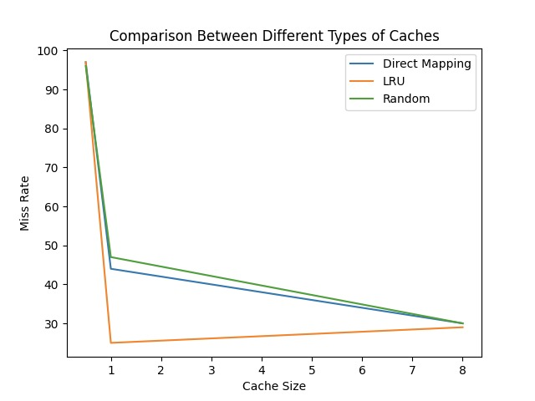

**Part C) N-Way Associative Set**

**LRU Replacement Policy:**

**Good Hit Rate:**

|  |  |  |  |  |  |  |  |  |  |  |
| --- | --- | --- | --- | --- | --- | --- | --- | --- | --- | --- |
| **N-set:** | **2** | | **4** | | **8** | | **16** | | **32** | |
| **Block Size**  **--------**  **Capacity** | **64** | | **64** | | **64** | | **64** | | **64** | |
| **Miss rate**  **(%)** | **# of misses** | **Miss rate**  **(%)** | **# of misses** | **Miss rate**  **(%)** | **# of misses** | **Miss rate**  **(%)** | **# of misses** | **Miss rate**  **(%)** | **# of misses** |
| **8 kB** | 22 | 1110 | 36 | 1815 | 39 | 2000 | 39 | 2000 | 39 | 2000 |

**Medium Hit Rate:**

|  |  |  |  |  |  |  |  |  |  |  |
| --- | --- | --- | --- | --- | --- | --- | --- | --- | --- | --- |
| **N-set:** | **2** | | **4** | | **8** | | **16** | | **32** | |
| **Block Size**  **--------**  **Capacity** | **4** | | **4** | | **4** | | **4** | | **4** | |
| **Miss rate**  **(%)** | **# of misses** | **Miss rate**  **(%)** | **# of misses** | **Miss rate**  **(%)** | **# of misses** | **Miss rate**  **(%)** | **# of misses** | **Miss rate**  **(%)** | **# of misses** |
| **1 kB** | 27 | 724 | 27 | 724 | 25 | 657 | 25 | 657 | 25 | 657 |

**Poor Hit Rate:**

|  |  |  |  |  |  |  |  |  |
| --- | --- | --- | --- | --- | --- | --- | --- | --- |
| **N-set:** | **2** | | **4** | | **8** | | **16** | |
| **Block Size**  **--------**  **Capacity** | **8** | | **8** | | **8** | | **8** | |
| **Miss rate**  **(%)** | **# of misses** | **Miss rate**  **(%)** | **# of misses** | **Miss rate**  **(%)** | **# of misses** | **Miss rate**  **(%)** | **# of misses** |
| **0.5 kB** | 99 | 2504 | 99 | 2504 | 99 | 2504 | 99 | 2504 |

**Random Replacement Policy:**

**Good Hit Rate:**

|  |  |  |  |  |  |  |  |  |  |  |
| --- | --- | --- | --- | --- | --- | --- | --- | --- | --- | --- |
| **N-set:** | **2** | | **4** | | **8** | | **16** | | **32** | |
| **Block Size**  **--------**  **Capacity** | **64** | | **64** | | **64** | | **64** | | **64** | |
| **Miss rate**  **(%)** | **# of misses** | **Miss rate**  **(%)** | **# of misses** | **Miss rate**  **(%)** | **# of misses** | **Miss rate**  **(%)** | **# of misses** | **Miss rate**  **(%)** | **# of misses** |
| **8 kB** | 28 | 720 | 30 | 748 | 28 | 701 | 28 | 714 | 28 | 704 |

**Medium Hit Rate:**

|  |  |  |  |  |  |  |  |  |  |  |
| --- | --- | --- | --- | --- | --- | --- | --- | --- | --- | --- |
| **N-set:** | **2** | | **4** | | **8** | | **16** | | **32** | |
| **Block Size**  **--------**  **Capacity** | **4** | | **4** | | **4** | | **4** | | **4** | |
| **Miss rate**  **(%)** | **# of misses** | **Miss rate**  **(%)** | **# of misses** | **Miss rate**  **(%)** | **# of misses** | **Miss rate**  **(%)** | **# of misses** | **Miss rate**  **(%)** | **# of misses** |
| **1 kB** | 41 | 1069 | 44 | 1162 | 44 | 1164 | 46 | 1212 | 46 | 1217 |

**Poor Hit Rate:**

|  |  |  |  |  |  |  |  |  |
| --- | --- | --- | --- | --- | --- | --- | --- | --- |
| **N-set:** | **2** | | **4** | | **8** | | **16** | |
| **Block Size**  **--------**  **Capacity** | **8** | | **8** | | **8** | | **8** | |
| **Miss rate**  **(%)** | **# of misses** | **Miss rate**  **(%)** | **# of misses** | **Miss rate**  **(%)** | **# of misses** | **Miss rate**  **(%)** | **# of misses** |
| **0.5 kB** | 96 | 2446 | 96 | 2425 | 94 | 2391 | 95 | 2403 |

**Conclusion of part C:**

In this part of the lab experiment, I used different sizes and different block replacement policies and observed the behavior of the hit and miss rates of the program. I read the lecture notes in this manner and my outcomes were in-line with the theoretical expectation. The best effect of N-way associativity can be seen from the medium and poor hit rate configurations. This is because in the best-case configuration the cache is sufficient for the program. In the medium rate configuration, the miss rate of the cache first decreased. Thus, it proves that if we increase the associativity degree, we decrease the chance of conflict misses and for this reason, we obtain a better hit rate every time we increase N.

Hence, we can say that the best set number to use in this case was 8. For the rate of change in the miss rate, we can say that it first had a positive slope. We can say this because in the medium rate configuration, the miss rate dropped from %30 to %28 when we changed the associativity to 8 from 4. As you can see the miss count was 748 (from set N = 4 to N = 8) and then 701 (from set N = 4 to N = 8) but at last the rate of change turned into -%2.

**Lab 6 Cache Report 2**

**Matrix with N=25:**

**Row Summation Data Table:**

|  |  |  |  |  |  |  |  |  |  |  |
| --- | --- | --- | --- | --- | --- | --- | --- | --- | --- | --- |
| **Block Size**  **\**  **Capacity** | **4** | | **8** | | **16** | | **32** | | **64** | |
| **Miss rate (%)** | **# of misses** | **Miss rate**  **(%)** | **# of misses** | **Miss rate**  **(%)** | **# of misses** | **Miss rate**  **(%)** | **# of misses** | **Miss rate**  **(%)** | **# of misses** |
| **0.5 kB** | 30 | 214 | 79 | 563 | 91 | 647 | 73 | 519 | 39 | 277 |
| **1 kB** | 29 | 203 | 32 | 229 | 72 | 513 | 73 | 519 | 39 | 277 |
| **2 kB** | 26 | 184 | 17 | 118 | 25 | 175 | 31 | 223 | 19 | 133 |
| **4 kB** | 24 | 169 | 14 | 184 | 10 | 73 | 10 | 70 | 8 | 60 |
| **8 kB** | 24 | 169 | 14 | 97 | 10 | 73 | 10 | 70 | 8 | 60 |

**Column Summation Data Table:**

|  |  |  |  |  |  |  |  |  |  |  |
| --- | --- | --- | --- | --- | --- | --- | --- | --- | --- | --- |
| **Block Size**  **\**  **Capacity** | **4** | | **8** | | **16** | | **32** | | **64** | |
| **Miss rate**  **(%)** | **# of misses** | **Miss rate**  **(%)** | **# of misses** | **Miss rate**  **(%)** | **# of misses** | **Miss rate**  **(%)** | **# of misses** | **Miss rate**  **(%)** | **# of misses** |
| **0.5 kB** | 22 | 171 | 12 | 91 | 7 | 52 | 5 | 39 | 5 | 40 |
| **1 kB** | 22 | 169 | 12 | 89 | 6 | 50 | 4 | 33 | 4 | 30 |
| **2 kB** | 22 | 168 | 11 | 88 | 6 | 49 | 4 | 30 | 3 | 25 |
| **4 kB** | 21 | 165 | 11 | 84 | 6 | 45 | 3 | 26 | 2 | 17 |
| **8 kB** | 21 | 165 | 11 | 84 | 6 | 45 | 3 | 26 | 2 | 17 |

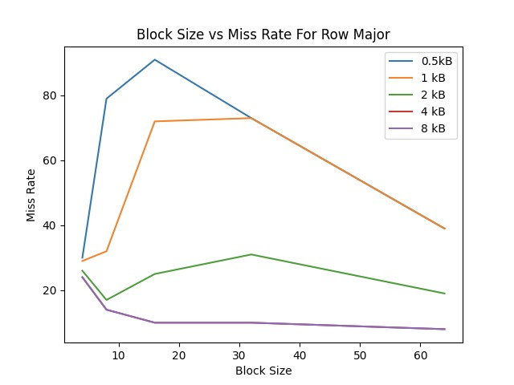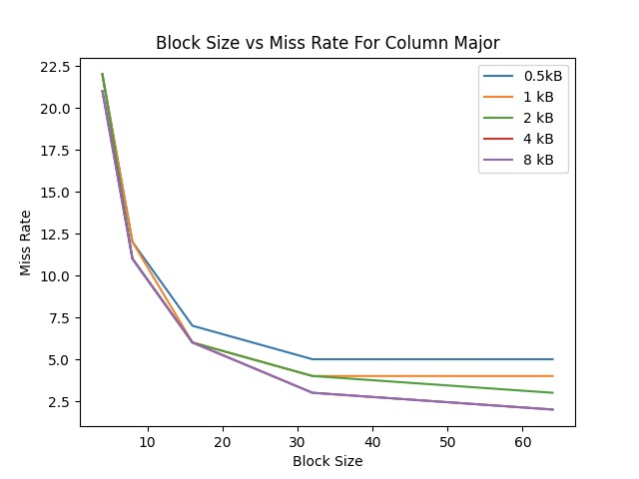

**Part b)**

**LRU Replacement:**

|  |  |  |  |  |  |  |
| --- | --- | --- | --- | --- | --- | --- |
| **Capacity \Block Size** | **8** | | **16** | | **64** | |
| **Miss rate(%)** | **# of misses** | **Miss rate(%)** | **# of misses** | **Miss rate (%)** | **# of misses** |
| **0.5 kB** | **-** | **-** | 8 | 653 | **-** | **-** |
| **1 kB** | 15 | 104 | - | - | - | - |
| **4 kB** | - | - | - | - | 2 | 12 |

In the good hit rate scenario, the cache capacity is 2^12 byte (4 kb) and 1 block is 2^8 Byte (it has 64 words). So, in fully associative cache there is 1 set that holds 16 blocks. Therefore, we see better “good hit rates” in 4kb and 8 kb because bigger cache capacity reduces the capacity misses. Furthermore, in the direct mapping our good hit rate was %92 but in fully associative cache, our good hit rate changed to %98 and the number of misses decreased from 60 to 12. Since the associativity degree increases from 1 to full, the conflict misses decrease, therefore we got a better hit rate. In addition to that LRU is a specific technic to choose an efficient place for the new coming data because with LRU, you only overwrite the least used data, and it decreases the conflict misses. However, in direct mapping you don’t use any replacement technic, you just trash data that is found with a mapping function. Thus, in general we expect to get better results by using LRU.

In the medium hit rate scenario, the cache capacity is 2^10 byte (1 kb) and 1 block is 2^5 Byte (it has 8 words). So, in fully associative cache there is 1 set that holds 32 blocks. In the direct mapping our medium hit rate was %68 but in fully associative cache, our medium hit rate changed to %85 and the number of misses decreased from 229 to 104. Since the associativity degree increases from 1 to full, the conflict misses decrease, therefore we got a better hit rate. In addition to that with LRU, we decrease the conflict misses. Thus, in general we expect to get better results by using LRU.

In the poor hit rate scenario, the cache capacity is 2^9 byte (0.5 kb) and 1 block is 2^5 Byte (it has 8 words). So, in fully associative cache there is 1 set that holds 16 blocks. In the direct mapping our poor hit rate was %9 but in fully associative cache, our poor hit rate changed to %8 and the number of misses increased from 647 to 653. Since the associativity degree increases from 1 to full, normally we expect to see that conflict misses to decrease, however it increases in the poor hit case. Since direct mapping and fully associative miss count are very close to each other, the reason for this can be the fact that the cache capacity is very small for our matrix, and we may not comfortably observe the differences between direct mapping and fully associative cache. So, the experimental result may have been due to the selection of sizes, writing of the program code or any other factor.

**Random Replacement:**

|  |  |  |  |  |  |  |
| --- | --- | --- | --- | --- | --- | --- |
| **Capacity \Block Size** | **8** | | **16** | | **64** | |
| **Miss rate(%)** | **# of misses** | **Miss rate(%)** | **# of misses** | **Miss rate (%)** | **# of misses** |
| **0.5 kB** | - | - | 12 | 625 | - | - |
| **1 kB** | 30 | 214 | - | - | - | - |
| **4 kB** | - | - | - | - | 2 | 12 |

With random replacement technic; in the experiment, we got worst results with medium and good hit rate cases, but we got a slightly better hit rate with the poor hit rate case. It is because random replacement just picks a random place, and it has no guarantee that it performs constantly better results. However, LRU is a more specific technic to choose an efficient place for the new coming data because with LRU, you only overwrite the least used data, and it decreases the conflict misses. Thus, in general we expect to get better results by using LRU just like we see in medium and good hit rate cases. Another reason is associativity degree: Since the associativity degree increases from 1 to full, the conflict misses decrease, therefore we got a better hit rate.

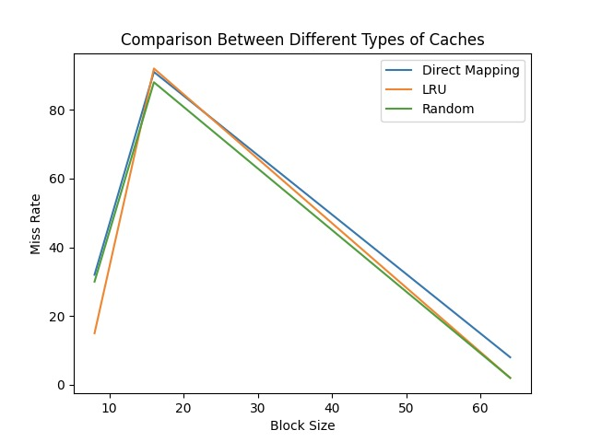

**Part C)**

**LRU Replacement:**

**For Medium Hit Rate:**

|  |  |  |  |  |  |  |  |  |
| --- | --- | --- | --- | --- | --- | --- | --- | --- |
| **N-set:** | **2** | | **4** | | **8** | | **16** | |
| **Block Size**  **--------**  **Capacity** | **8** | | **8** | | **8** | | **8** | |
| **Miss rate**  **(%)** | **# of misses** | **Miss rate**  **(%)** | **# of misses** | **Miss rate**  **(%)** | **# of misses** | **Miss rate**  **(%)** | **# of misses** |
| **1 kB** | 38 | 273 | 19 | 133 | 16 | 112 | 15 | 104 |

**For Bad Hit Rate:**

|  |  |  |  |  |  |  |  |  |
| --- | --- | --- | --- | --- | --- | --- | --- | --- |
| **N-set:** | **1** | | **2** | | **4** | | **8** | |
| **Block Size**  **--------**  **Capacity** | **16** | | **16** | | **16** | | **16** | |
| **Miss rate**  **(%)** | **# of misses** | **Miss rate**  **(%)** | **# of misses** | **Miss rate**  **(%)** | **# of misses** | **Miss rate**  **(%)** | **# of misses** |
| **0,5 kB** | 91 | 647 | 92 | 653 | 92 | 653 | 92 | 653 |

**For Good Hit Rate:**

|  |  |  |  |  |  |  |  |  |
| --- | --- | --- | --- | --- | --- | --- | --- | --- |
| **N-set:** | **2** | | **4** | | **8** | | **16** | |
| **Block Size**  **--------**  **Capacity** | **64** | | **64** | | **64** | | **64** | |
| **Miss rate**  **(%)** | **# of misses** | **Miss rate**  **(%)** | **# of misses** | **Miss rate**  **(%)** | **# of misses** | **Miss rate**  **(%)** | **# of misses** |
| **4 kB** | 12 | 84 | 2 | 12 | 2 | 12 | 2 | 12 |

**Random Replacement:**

**For Medium Hit Rate:**

|  |  |  |  |  |  |  |  |  |
| --- | --- | --- | --- | --- | --- | --- | --- | --- |
| **N-set:** | **2** | | **4** | | **8** | | **16** | |
| **Block Size**  **--------**  **Capacity** | **8** | | **8** | | **8** | | **8** | |
| **Miss rate**  **(%)** | **# of misses** | **Miss rate**  **(%)** | **# of misses** | **Miss rate**  **(%)** | **# of misses** | **Miss rate**  **(%)** | **# of misses** |
| **1 kB** | 36 | 254 | 31 | 219 | 25 | 180 | 31 | 223 |

**For Bad Hit Rate:**

|  |  |  |  |  |  |  |  |  |
| --- | --- | --- | --- | --- | --- | --- | --- | --- |
| **N-set:** | **1** | | **2** | | **4** | | **8** | |
| **Block Size**  **--------**  **Capacity** | **16** | | **16** | | **16** | | **16** | |
| **Miss rate**  **(%)** | **# of misses** | **Miss rate**  **(%)** | **# of misses** | **Miss rate**  **(%)** | **# of misses** | **Miss rate**  **(%)** | **# of misses** |
| **0,5 kB** | 91 | 647 | 89 | 634 | 89 | 633 | 88 | 628 |

**For Good Hit Rate:**

|  |  |  |  |  |  |  |  |  |
| --- | --- | --- | --- | --- | --- | --- | --- | --- |
| **N-set:** | **2** | | **4** | | **8** | | **16** | |
| **Block Size**  **--------**  **Capacity** | **64** | | **64** | | **64** | | **64** | |
| **Miss rate**  **(%)** | **# of misses** | **Miss rate**  **(%)** | **# of misses** | **Miss rate**  **(%)** | **# of misses** | **Miss rate**  **(%)** | **# of misses** |
| **4 kB** | 8 | 60 | 2 | 12 | 2 | 12 | 2 | 12 |

**Conclusion of the part C:**

In this part of the lab experiment, I used different sizes and different block replacement policies and observed the behavior of the hit and miss rates of the program. I read the lecture notes in this manner and my outcomes were in-line with the theoretical expectation. The best effect of N-way associativity can be seen from the medium and poor hit rate configurations. This is because in the best-case configuration the cache is sufficient for the program. In the medium rate configuration, the miss rate of the cache first decreased. However, after the set number 8, miss rate of the cache increased and set associativity had a diminishing return.

Hence, we can say that the best set number to use in this case was 8. For the rate of change in the miss rate, we can say that it first had a positive slope. We can say this because in the medium rate configuration, the miss rate dropped from 36 to 31 when we changed the associativity to 4 from 2. After this the miss rate dropped from 31 to 25 when we changed the associativity to 8 from 4. As you can see the rate of change was %13.9 (from set N = 2 to N = 4) and then %19.4 (from set N = 4 to N = 8) but at last the rate of change turned into -%19.4. Thus, it proves that if we increase the associativity degree, we decrease the chance of conflict misses and for this reason, we obtain a better hit rate every time we increase N.